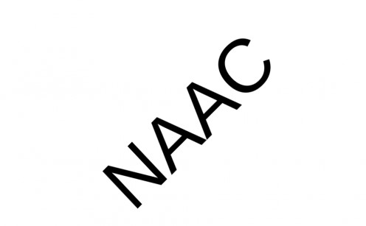Gender Equity:
Pradeep Memorial Comprehensive College of Education is a co-education institution and is an ideal and very safe College for women. This is one of the reason that share of women is higher in College than their counter parts. Faculty is very sensitive on the gender concerns. During the last three years College made many initiatives on gender Equity, such as
Women Development Cell- roles and responsibilities of cell is to highlight the diversity , plan strategy to bring equity through different media.
Representation to women faculty and students in Committees- Good number of women faculty and student are associated in the decision making process of the College. Many such committees are headed by women. It encourages leadership quality and skill of decision making among women.
Add-on Course Women Education and Development- A sixteen hours Add-on Course is organized which covers the following areas:
- Status of Women in India
- Educational Status of women
- Constitutional provisions on Equity
- Commercial Exploitation of Women
- Women at work place
- Domestic violence
- Women as a Role Model
- Sexual harassment of women

Events are for dealing with Gender issues like celebration of Beti Swabhiman Divas- “Beti organized Bachao Beti Padao” scheme; Self-Defense Training Camp for Girls in collaboration with Delhi Police for providing training on self-defense techniques and martial arts,educating about the good touch & bad touch to the school students through session imparted to train the school teachers. Celebration of International Women’s Day and National Girls Day. The ratio of male to female students is approx. 3:2 and the Institute predominantly has female faculty too.

